**2018 National Economic Impact of the U.S. Coastal Port System: *Executive Summary***

**Conducted by Martin Associates**

[***www.martinassoc.net***](http://www.martinassoc.net)

**March 2019**



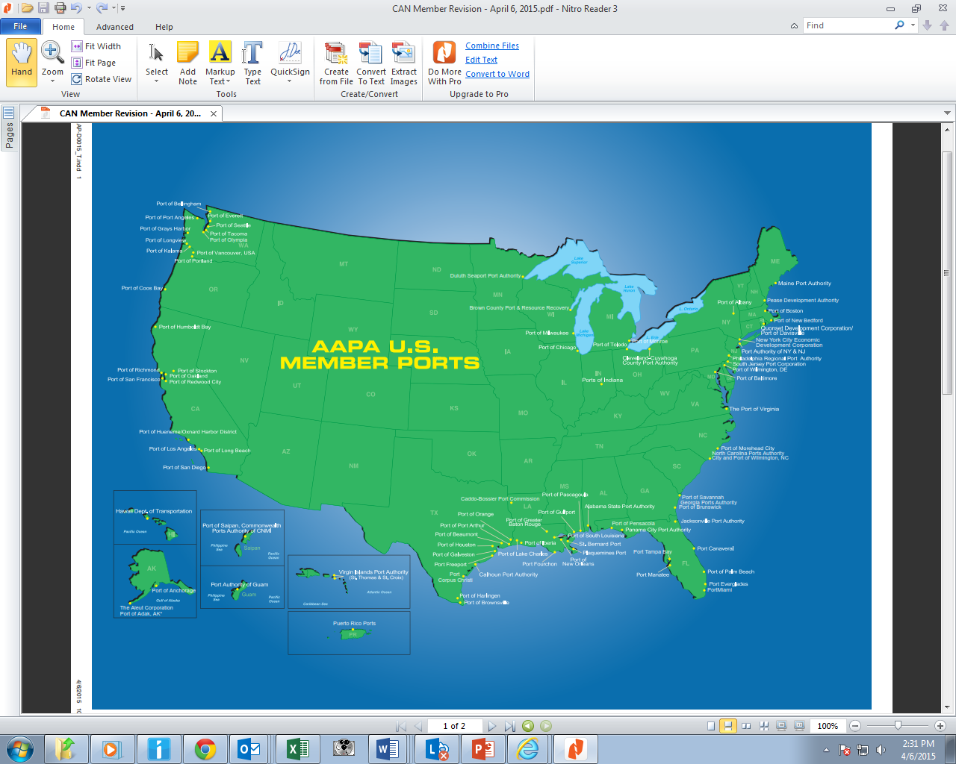

**All photos courtesy of www.aapa-ports.org**

**Overview**

Over the past 33 years, Martin Associates has conducted more than 750 seaport economic impact studies for the majority of ports throughout the United States. As a service to the American Association of Port Authorities (AAPA), Martin Associates has prepared this National Economic Impact Study of the U.S. Coastal Port System. To determine the impact, Martin Associates used a combination of its own 64 individual seaport impact models that have been developed in the last three years along with prototype models developed from these 64 seaport-specific models. The seaport models include ports on the West Coast, Atlantic Coast, Gulf Coast and the Great Lakes.

**Economic Impact Analysis**

Martin Associates began this study by using its 64 individual seaport impact models which were developed based on detailed interviews with over 14,000 port service providers. Using these models, Martin Associates developed composite prototype models for the U.S. coastal port system. Additionally, Martin Associates used a combination of 2018 international port cargo statistics supplied by USA Trade On-Line, as well as individual port statistics for 2018, which were supplied by the seaports and terminals handling both international and domestic cargo. These databases were used to calibrate each of the impact models to estimate the impacts of the U.S. coastal port system.

The resulting economic impact models can be used for updates, as well as to test the sensitivity of the impacts to changes in such factors as marine cargo tonnage levels; labor productivity and work rules; new marine facilities development and expansion; the impacts of harbor and channel deepening; the impact of port shutdowns such as the 2002 West Coast port shutdown and the recent West Coast port slowdowns that occurred during the 2014-2015 contract negotiations; the impact of national policy issues such as the impact of the Jones Act and cargo preference laws; and the impact of trade policy, such as the economic impact on the Marine Transportation System of the Section 201 Steel Import Restriction, and the potential economic impact of the current trade negotiations.

**2018 National Economic Impacts of the U.S. Deepwater Port System- Summary of Results**

**2018 National Economic Impacts the U.S. Deepwater Port System- Summary of Results**

There are **2.2 million direct, induced and indirect jobs** in the United States that are generated by the U.S. coastal port sector. Of the 2.2 million jobs, **652,078 jobs are directly** generated by the marine cargo and vessel activity. As the result of local and regional purchases by those 652,078 individuals holding the direct jobs, an additional **1,056,942 induced jobs** are supported in the national economy. **501,555 indirect jobs** are supported by $41.0 billion of local purchases by businesses supplying services at the marine terminals and by businesses dependent upon the cargo and vessel activity. An additional **28.6 million jobs are with exporters/importers and users** of the nation’s coastal seaports.

In 2018, marine cargo activity generated approximately **$5.4 trillion of total economic activity**, accounting for nearly 26 percent of the nation’s $20.9 trillion Gross Domestic Product reported in the fourth quarter of 2018. Of this $5.4 trillion, $**184.1 billion accounts for direct business** revenue that was received by the firms providing services to the cargo and vessels calling at the nation’s seaports. From this $184.1 billion of direct business revenue, the firms use a

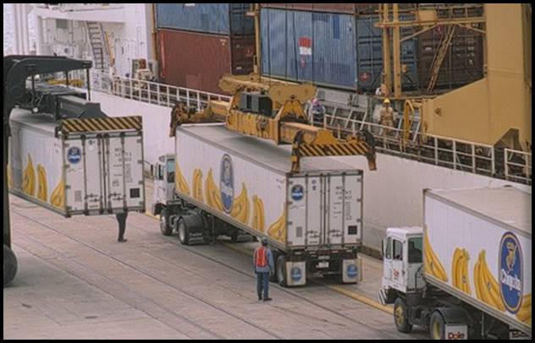

portion, $40.9 billion, to pay the salaries of 652,078 direct job holders. This equates to an average annual income of $62,800, compared to an average overall U.S. mean salary of $50,620 in 2017.

In addition to the direct salary paid from the $184.1 billion of direct business revenue, the firms providing the direct services also make purchases, totaling about **$41.0 billion**.

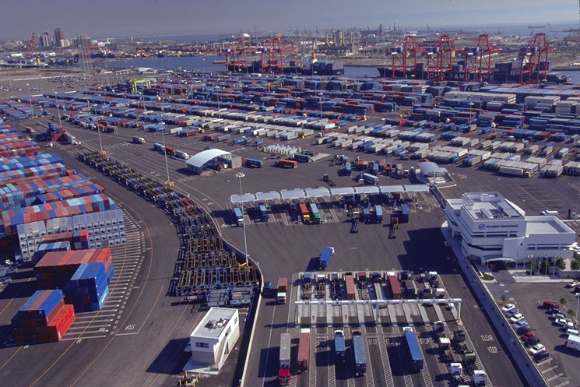

Another component of the $5.4 trillion economic value is the **re-spending effect that occurs due to consumption purchases by the direct jobs holders**. This is not included in the direct business revenue as it occurs from the portion of the direct income that is used by individuals for purchases of goods and services. In 2018, the **re-spending and local consumption impact is estimated at $139.2 billion. The remaining $5.1 trillion represents the value of the output to the national economy** that is created due to the cargo moving via the coastal ports. This includes the value added at each stage of producing an export cargo, as well as the value added at each stage of production for the firms using imported raw materials and intermediate products that flow via the marine terminals.

**There were $378.1 billion of total federal, state, and local taxes** generated by maritime activity at the coastal ports in 2018, including $47.1 billion of direct, induced and indirect federal, state and local tax revenue, and an additional $331.0 billion of federal state and local tax revenue created due to the economic activity of the exporters and importers using the nation’s deep-water coastal port system.

**2014 vs. 2018 National Economic Impact of U.S. Deepwater Port System Comparisons**

A similar methodology was used by Martin Associates to estimate the national impact of the U.S. coastal ports in 2014. The key difference in methodology is in the number of specific seaport models used as baseline models in each study year.

The number of seaport specific models increased from 57 to 64 models in the 2018 study.

Since 2014, total jobs supported by the cargo moving via the nation’s coastal water ports increased **from 23.1 million jobs to 30.8 million jobs,** and the total economic value of the nation’s coastal ports increased **from $4.6 trillion in 2016 to $5.4 trillion in 2018**. **This growth in jobs and economic value of the seaports reflects the growth of 165 million tons of international cargo since 2014, and underscores the importance of continued investment in port and intermodal infrastructure by both the public and private sectors to support the growing importance of international trade to the U.S. economy.**

**DEFINITIONS**

 The following Exhibit demonstrates how seaport activity impacts the local, regional and national economies. As this exhibit indicates, the marine cargo and vessel activity initially generate business revenue to the firms supplying marine services. This revenue is used to purchase employment (direct jobs) to provide the services, to pay stockholders and for retained earnings, and to purchase goods and services from local firms, as well as national and international firms (creating indirect jobs with these firms). Businesses also pay taxes from the business revenue.

**Flows of Economic Impacts Throughout the Economy**



The employees hired by the firms receive wages and salaries (personal income), a portion of which is saved, while another portion is used to buy goods and services such as food, housing, clothing, health care, etc. These purchases create a re-spending impact throughout the economy, known as the personal income multiplier. As a result of these local purchases, additional jobs (known as induced jobs) are created in the local economy. Local purchases are also made by the firms directly dependent upon the seaport, including petroleum refineries and petrochemical plants, wall board producers importing gypsum via a coastal port, steel mills receiving ore and slab over the docks, as well as firms providing services to a specific port such as stevedores, terminal operators, trucking firms and railroads, steamship lines and agents, and freight forwarders. The local purchases made by directly dependent firms create indirect jobs. Finally, taxes are paid by individuals employed with the firms providing the services to the marine terminals and by the firms directly dependent upon the Port.

Four types of impacts were measured for this report:

* Jobs;
* Employee earnings;
* Business revenue;
* State, local and federal taxes.

With respect to jobs, four types of job impacts were measured. These are direct, induced, indirect and related jobs. The job impacts are defined as follows:

* Direct jobs are those jobs with local firms providing support services to the seaport. These jobs are dependent upon this activity and would suffer immediate dislocation if the seaport activity were to cease. Seaport direct jobs include jobs with railroads and trucking companies moving cargo to and from the marine terminals and private terminals, members of the International Longshoremen's Association (ILA), the International Longshore and Warehouse Union (ILWU) and non-ILA and non-ILWU dockworkers, steamship agents, freight forwarders, ship chandlers, warehouse operators, bankers, lawyers, terminal operators, and stevedores.
* Induced jobs are jobs created locally and throughout the national economy due to purchases of goods and services by those directly employed. These jobs are with grocery stores, the local construction industry, retail stores, health care providers, local transportation services, local and state government agencies providing public services and education to those directly employed, and businesses providing professional and business services in support of those directly employed. These goods and services would also be discontinued if seaport activity were to cease.
* Indirect jobs are those jobs generated in the national economy as the result of local purchases by the firms directly dependent upon seaport activity. These jobs include jobs in local office supply firms, equipment and parts suppliers, maintenance and repair services, insurance companies, consulting and other business services. If port operations were discontinued, these indirect purchases and the associated jobs and income would also be discontinued.
* Related jobs are with manufacturing and distribution firms -- such as steel fabrication firms using the steel imported through the marine terminals, the construction industry consuming construction materials moving via the coastal ports, manufacturers producing or consuming containerized cargo, retail outlets and distribution centers handling imported containerized cargo, and firms producing and consuming dry and liquid bulk cargoes such as petrochemical firms. Related jobs are not dependent upon the seaport marine terminals to the same extent as are the direct, induced and indirect jobs. It is the demand for the final product, i.e. steel products, that creates the demand for the employment with these shippers/consignees, not the use of a particular seaport or marine terminal. It is to be emphasized that the employment with firms counted as directly, induced and indirectly dependent upon the port activities are excluded from the related jobs to avoid double counting.

The employee earnings consist of wages and salaries and include a re-spending effect (purchases of goods and services by those directly employed), while business revenue consists of total business receipts by firms providing services in support of the marine activity. State, local and federal taxes include taxes paid by individuals, as well as firms dependent upon the seaport activity.

The study is based on interviews with more than 14,000 firms providing services to the cargo and vessels handled at the nation’s coastal marine terminals. In general, these firms represent more than 95 percent of the firms providing services to the nation’s seaport community, underscoring the defensibility of the study.

**METHODOLOGY**

           This rest of this chapter provides an overview of the methodology used by Martin Associates to develop the economic impacts.

## 1.       IMPACT STRUCTURE

The four types of economic impacts are created throughout various business sectors of the state and local economies. Specifically, four distinct economic sectors are impacted as a result of activity at the marine terminals.  These are the:

▪     Surface Transportation Sector;

▪     Maritime Services Sector;

▪     Shippers/Consignees using the Port;

▪     Port Authority.

Within each sector, various participants are involved.  Separate impacts are estimated for each of the participants.  A discussion of each of the economic impact sectors is provided below, including a description of the major participants in each sector.

### 1.1       The Surface Transportation Sector

The surface transportation sector consists of both the railroad and trucking industries, as well as pipelines.  The trucking firms and railroads are responsible for moving the various cargoes between the marine terminals and the inland origins and destinations.

### 1.2       The Maritime Services Sector

            This sector consists of numerous firms and participants performing functions related to the following maritime services:

▪     Cargo Marine Transportation;

▪     Vessel Operations;

▪     Cargo Handling;

▪     Federal, State, and Local Government Agencies

A brief description of the major participants in each of these four categories is provided below:

▪     Cargo Marine Transportation - Participants in this category are involved in arranging for inland and water transportation for export or import freight.  The freight forwarder/customshouse broker is the major participant in this category.  The freight forwarder/customshouse broker arranges for the freight to be delivered between the terminals and inland destinations, as well as the ocean transportation.  This function performed by freight forwarders and customshouse brokers is most prevalent for general cargo commodities.

▪     Vessel Operations - This category consists of several participants.  The steamship agents provide a number of services for the vessel as soon as it enters the port; the agents arrange for pilot services and towing, for medical and dental care of the crew, and for ship supplies.  The agents are also responsible for vessel documentation.  In addition to the steamship agents arranging for vessel services, those providing the services include:

-                      Chandlers ‑ supply the vessels with ship supplies (food, clothing, nautical equipment, etc.);

‑           Towing firms ‑ provide the tug service to guide the vessel to and from port; also these firms perform linehaul towing services.

-           Pilots - assist in navigating the vessels along the ship channel to and from the public and private marine terminals;

‑           Bunkering firms ‑ provide fuel to the vessels;

‑           Marine surveyors ‑ inspect the vessels and the cargo;

‑           Shipyards/marine construction firms ‑ provide repairs, either emergency or scheduled as well as marine pier construction and dredging.

▪     Cargo Handling ‑ This category involves the physical handling of the cargo at the terminals between the land and the vessel.  Included in this category are the following participants:

‑           Longshoremen ‑ include members of the International Longshoremen's Association (ILA) and the International Longshore and Warehouse Union (ILWU), as well as non-ILA and non-ILWU dockworkers that are involved in the loading and unloading of cargo from the vessels, as well as handling the cargo prior to loading and after unloading.

‑           Stevedoring firms ‑ manage the longshoremen and cargo‑handling activities.

‑          Terminal operators ‑ are often stevedoring firms who operate the maritime terminals where cargo is loaded and off-loaded.

‑           Warehouse operators ‑ store cargo after discharge or prior to loading and consolidate cargo units into shipment lots.

▪     Government Agencies ‑ This service sector involves Federal, state and local government agencies that perform services related to cargo handling and vessel operations at the Port., U.S. Customs and Border Protection, U.S. Department of Labor, U.S. Department of Agriculture, U.S. Coast Guard, the Army Corps of Engineers, and U.S. Department of Commerce employees are involved.

### 1.3       Shippers/Consignees

Two categories of shippers and consignees are considered in the analysis:  those that are totally dependent on the public and privately-owned marine terminals and those located throughout the regional economy whose business is only related to the port.  Those in the first category would most likely shut down operations if the marine terminals were not available for their use, while those in the second category would ship or receive materials via another port.  Related jobs consist of jobs with steel fabrication firms, users and producers and consumers of containerized cargo and breakbulk cargo, and farmers producing the grain and crops for export.  Dependent shippers/consignees include employees of the oil refineries and petrochemical plants that are dependent upon the receipt of crude and chemicals by vessel/barge and the shipment of refined product by vessel/barge, as well as plants on the ship channels that are dependent upon the receipt or shipments such as steel products, lumber, cement and other miscellaneous breakbulk cargoes.

### 1.4       Port Authority

The Port Authority sector includes those individuals employed by the public ports whose purpose is to oversee port activity at the marine terminals owned and operated by the public ports.

## 2.         SUMMARY OF METHODOLOGY

The purpose of this section is to provide a summary of the methodological approach used to estimate the economic impacts of the vessel and cargo activity.

### 2.1       Data Collection

            The cornerstone of the Martin Associates approach is the collection of detailed baseline impact data from firms providing services at the marine terminals.  To ensure accuracy and defensibility, the baseline impact data was collected from interviews with more than 14,000 firms in the nation’s maritime community.

### 2.2       Direct Jobs, Income and Revenue Impacts

The results of these interviews were then used to develop the baseline direct job, revenue and income impacts for the economic sectors and job categories associated. Direct tax impacts are estimated at a federal, state, county and local level based on actual per capita income levels as published by the Tax Foundation.

### 2.1       Induced Impacts

Induced impacts are those generated by the purchases of the individuals employed as a result of seaport activity.  For example, a portion of the personal earnings received by those directly employed due to activity at the marine terminals is used for purchases of goods and services, both regionally, as well as out‑of‑the region.  These purchases, in turn, create additional jobs in which each port is classified as induced.  To estimate these induced jobs, the national personal earnings multiplier for marine transportation was developed from the Bureau of Economic Analysis, Regional Input-Output Modeling System (RIMSII).  This personal earnings multiplier is used to estimate the total personal earnings generated nationally due the activity at the public and private marine terminals.  A portion of this total personal earnings impact is next allocated to specific purchases (as determined from consumption data for each regional area in which one of the 64 ports is located), as developed from the U.S. Bureau of Labor Statistics, Consumer Expenditure Survey.  These purchases are next converted into induced jobs in the regional economy.

### 3.4       Indirect Jobs

Indirect jobs are generated in the local economy as the result of purchases by firms that are directly dependent upon cargo and vessel activity at the marine terminals, including the dependent shippers/consignees with terminals located along the shipping channels.  These purchases are for goods and services such as office supplies and equipment, maintenance and repair services, communications and utilities, transportation services and other professional services.  To estimate the indirect economic impact, the amount purchases, by type of purchase, were collected from each of the firms interviewed.  These purchases were then combined with employment to sales ratios in local supplying industries, developed from the U.S. Bureau of Economic Analysis Regional Input-Output Modeling System for the regions in which the ports are located.  The indirect job ratios also account for the spin-off effects from multiple rounds of supply chains that are required to provide the regionally purchased goods and services.

### 3.5       Related Impacts

Related impacts measure the jobs with shippers and consignees moving cargo through the public and private terminals.  These jobs are estimated based on the value per ton of the commodities exported and imported via the each of the seaports and the associated jobs to value of output ratios for the respective producing and consuming industries located throughout the United States. The value per ton of each of the key commodities moving via the ports was developed from USA Trade OnLine, a data base developed by the U.S. Bureau of Census.  The average value per ton for each commodity moving over the marine terminals at each of the ports was then multiplied by the respective tonnage moved in 2018.  Ratios of jobs to value of output for the corresponding consuming and producing industries were developed by Martin Associates from the U.S. Bureau of Economic Analysis, Regional Input-Output Modeling System.  These jobs to value coefficients include the spin-off impacts that would occur in order to produce the export commodity or use the import commodity in production.   The ratios of jobs to value of export or import cargo were then combined with the value of the respective commodities moving via the public and private terminals to estimate related jobs and the spin-off jobs to support the export and import industries.  Similarly, the respective income and output multipliers were used to estimate the related personal income impact as well as the total value of economic output and taxes generated by the coastal ports.  It is to be emphasized that care was taken to control for double counting of the direct, induced and indirect impacts.

###